**Avatar: The Way of Water**

**Final Project**

Hannah Darroch

Introduction to Social Media

Professor Kristin Blitch

December 9th, 2022

**Background**

*Avatar: The Way of Water*, is one of the most anticipated movie releases in history. It is the sequel to the highest grossing movie in cinematic history, *Avatar*. *Avatar* was released in 2009, 13 years ago, grossing $2,922,917,914 over its lifetime and was on the big screen for 10 months. The squeal, *Avatar: The Way of Water*, has been under development since 2010. *Avatar* was considered a complete game changer in the movie industry and paved the way for high special effect movies to come along. Originally planned to release in late 2014 to early 2015, we ask ourselves why did *Avatar: The Way of Water* take so long to create and how is there still this much hype around the movie. Firstly, James Cameron, the director, was determined to change the game again and make something no one else has. The film is based underwater, which took years for him to get the underwater CGI special effects perfect. Creating a movie with special effects underwater has been extremely difficult for years and needed major updates, but James Cameron took on the challenge and perfected it. The actors also had to train to hold their breath for long periods of time to shoot underwater. Cameron wanted the film to be as authentic as possible, which included filming underwater. “Cameron had his cast train with “the world’s best breath-hold specialists” so that he could film extended long takes underwater. Winslet held her breathe for seven minutes, while Sigourney Weaver previously revealed she got up to six and a half minutes” (Sharf 2022). Additionally, another reason this film took so long was due to the pandemic. The pandemic completely halted the industry, delaying almost every movie in production. The upcoming sequels also had a role to play with the delay. The *Avatar* franchise has 5 different movies planned, 4 of which are upcoming. According to The New York Times, James Cameron said, “Writing those new movies took four years, and designing their different biomes, cultures and wardrobes took an extra five” (Cameron 2022). James Cameron wanted everything mapped out and ready for production before he started shooting for the second one. In the movie industry if you wait that long to release a sequel the hype and excitement is gone. We can see clearly for this franchise that is not the case. The anticipation for the sequel and the 3 other movies to come continues to increase. This movie is bound to make history, but with 13 years between the first movie and the second, the marketing plan is crucial to keep the anticipation and excitement at an all-time high for this movie.

**Introduction**

Since, *Avatar: The Way of Water* is so highly anticipated, our marketing strategy and plan is crucially important. The length between the first movie and second, makes our plan even more important. We must build anticipation and excitement for this movie, so that viewers feel they need to see this movie as soon as they can. We have been teasing this movie since 2010 to gain anticipation. After the extreme delays, we continued to make little announcements here and there to assure the movie is still happening and keep viewers interested. In 2020, we began to share pictures on social media of our set and filming. Additionally in 2020, James Cameron announced in an interview that they are almost done with Avatar 2 and 95% complete on Avatar 3. In April 2022, our pre-pre-release marketing plan began. We announced the title *Avatar: The Way of Water* on April 27, 2022, at CinemaCon. We also released the very first teaser trailer that drew anticipation to an all-time high, as viewers finally got a first look at this incredible production. For this marketing plan, we plan to utilize social media heavily to promote this film. We also are planning on using influencer marketing to reach a greater audience as well. We are pulling out all the stops to market this film. Everything from TV commercials, movie theater previews, social media teasers, billboards, interviews, and more. Our pre-event strategy starts in September as we begin to release more information. This strategy will end the day before the official red-carpet premiere, rumored to be held on December 12th, 2022. The during-event phase will kick off the day of the red-carpet premiere. The premiere part of the plan will utilize press reviews, articles, celebrities, influencers, and different media outlets. Additionally, we will utilize social media to promote the release as well. Finally, the post-event phase will begin when the film is out of theaters and released on DVD & Streaming services. This phase will be heavily promoted on social media, the internet, media outlets, and television. To help execute our marketing plan, we have come up with 3 different social media SMART goals. SMART is an acronym that stands for, specific, measurable, attainable, realistic/relevant, and time bound. Our first SMART goal is to increase our engagement rate on our social posts. We want to increase our engagement by posting multimedia content, at least once a week per platform. Our goal is to increase engagement by 3% per post. With Instagram, our engagement has been increasing each post by posting with 20th century studios. Recent posts have ranged from around 3.64% (posting alone) to around 20.86% (posting with 20th century studios). Our engagement has been steadily increasing over the past month, through likes and comments, across all platforms. Increasing our engagement will create more awareness and create more theater traffic. We want to increase our engagement by 3% within the next month. Our next SMART goal is to increase brand awareness. Since it has been so long since the first movie, we want to increase our following by 15% to increase brand awareness. By posting engaging content across platforms, we hope to achieve this. Additionally, we will be promoting our brand through articles and interviews on different media platforms. According to social blade, over the past 30 days our following on Instagram has increased by 40.23k (158%) (Social Blade 2022). According to Path Social, our following on Instagram has increased by 24.1k (Social Path 2022). While, there are some discrepancies between websites, it is clear this goal is perfectly attainable. Improving our following and brand awareness will lead to more consumers who go to the theater to watch the film, which leads to more profit. We want to increase our following by this amount within 3 weeks. Our final social media SMART goal is to increase website traffic by 5%, by including call to actions on our posts. We have already seen a slight increase of website traffic within the past month. Including call to actions on our post will increase the amount of clicks significantly. An increase in website traffic will increase our consumer base, tickets sold, and income. We want to increase our traffic within a month. Having these SMART goals outlined helps us measure our marketing plans' success.

**Campaign**

For our marketing campaign we will be using multiple different platforms to promote the film. We will be heavily marketing on TikTok and Instagram, along with some marketing on Twitter and Facebook. Since this movie is targeted towards almost everyone, we are using multiple platforms to target multiple audiences. We chose to heavily market on TikTok and Instagram, since these are the biggest platforms among ages 18-40. We will be utilizing TikTok to target the younger generation, anywhere from ages 16-25. We are targeting this age group because these are consumers who likely saw the first movie when they were younger. They will want to see the second because they loved the first, and the nostalgia factor since the first movie was a big part of their youth. We also chose TikTok because this platform has the highest engagement of any social media platform. By producing quality content, we can potentially go viral and reach a whole other set of audience that we wouldn’t have otherwise. When planning our marketing campaign, we came up with 3 different target market personas. Our first persona is Disney Debby, she is a recent college graduate who is a die-hard Disney fan. She is 22 years old, has no children, lives in a big city, works in marketing, and loves spending time with friends. Debby is exactly who we are targeting by creating content on TikTok. Our voice on TikTok will be more upbeat, playful, and personal to connect with the younger audience. We also chose to heavily market on Instagram due to it being one of the biggest social platforms. Instagram is popular with the younger generation, much like TikTok, but also is popular with the millennial generation, ages 26-41. Utilizing Instagram, we can target both generations, whereas with TikTok we aren’t. We also chose Instagram, due to the new feature that allows you to invite a collaborator. This feature puts the post on both accounts when the invite is accepted. This allows us to reach a wider audience and increase brand awareness. Our voice on this platform will be friendly, informational, and approachable. Along with Disney Debby, we created Sci-Fi Scott. Scott is 32, single without kids, works in engineering and is extremely smart. He is a bit of a nerd who loves video games and technology. Scott isn’t fond of social media, but he is on Instagram to keep up with his friends and favorite brands/companies. He is also on Twitter to keep up with the latest technology news. Both Debby and Scott are being targeted with Instagram. We are targeting teenagers, young adults, and technology and sci-fi fans. We are targeting teenagers and young adults, because they likely saw the first movie and have been anticipating the second for years. They are also Disney fans who are ecstatic to see the movie. We are also targeting technology and sci-fi fans on Instagram and Twitter because this movie uses revolutionary special effects and technology. It has completely changed the industry and technology and sci-fi fans will appreciate and admire how the movie was made and will want to see the incredible final product. In addition to TikTok and Instagram, we will be marketing on Twitter and Facebook. For Twitter, we chose this platform to target ages 25-35. This audience is more closely aligned with Sci-Fi Scott, than Instagram. While this age range is also targeted on Instagram, the audience on Twitter is completely different. This audience uses Twitter to see the latest updates in technology, which is why we have chosen this platform. The voice for Twitter will be more scientific, knowledgeable, and factual based to align with this audience. For Facebook, we will mainly be targeting ages 35-50, specifically parents and families. Our final persona is, Suburban Susan, she is married to her husband Kevin, and they have 2 children. Susan is an accountant, loves HGTV, cooking, loves sharing her family life on Facebook and being the best mom, she can be. Susan is the exact audience we are targeting on Facebook. We are targeting parents who want to take their kids to see this movie. Our voice on Facebook will be more warm, informational, and simple. The reason we chose to use Facebook to target this audience is because this platform is the main platform they use. These moms love to post about their family on Facebook and see all their friends' posts. Across the platforms we will be using the hashtags, #AvatarTheWayofWater, #Avatar, and #20thCenturyStudios. These hashtags align with our brand and 2 of them our unique to our franchise. We will be partnering with major media sites, like Vanity Fair, Entertainment Weekly, VOGUE, The New York Times, WIRED, and Forbes. We will invite these sites to exclusive interviews, the premier, and exclusive behind the scenes information for articles. Regarding influencer relationships, we won’t be using traditional influencer marketing where you pay for a post. We will be inviting influencers to the red-carpet premiere and utilizing them that way. By inviting bigger influencers to this event, they will not only be photographed and mentioned in the media, but most influencers will post when invited to a red-carpet event. They will usually post getting ready, at the event, at the after party, and more. This will increase our brand awareness and engagement, causing more people to go see the film. We will be inviting influencers like Charli and Dixie D’Amelio, Mr. Beast, Bryce Hall, Kristen Titus, Anna Sitar and more. We will also be inviting celebrities like Taylor Swift, Selena Gomez, Lady Gaga, Josh Gad, Kristin Bell, Harry Styles, Idina Menzel, and more. Inviting Influencers and Celebrities will create an additional buzz around the event and increased anticipation to see the film in theaters.

**Measurement & Tools**

We plan to analyze our campaign by using specific and measurable analytics. For social media, we will be using key performance indicators like engagement, reach and conversion. We will be looking at the engagement rate, utilizing likes/reactions, comments, shares, and saves. We will also be looking at our conversion rate and click through rate. These analytics will help us know what is working and what is not. We will be able to take these numbers and adjust our content accordingly to be more successful. We will be analyzing during all phases of the campaign. This will benefit our campaign in many ways. It allows us to know how our content is performing and how we can improve. It also will let us know if we need to create more content or include call to actions. For example, if we are in the during-event phase and box office numbers seem to be a little lower for the week. We can create a post encouraging our audience to go see the movie and even offer an incentive like a coupon. This will help increase our profit and theater traffic. We plan to use multiple tools to help develop, post, and analyze content. First, we plan to use Adobe Photoshop, Lightroom, and Premiere Pro for content editing. We also plan to use a content scheduler, like Hootsuite, to plan and schedule our content ahead of time. These tools will help our content be more professional and organized. We also will use Sprout Social and/or Hootsuite to see and compare our analytics. Finally, we will be utilizing Google Analytics to view our website analytics. These tools will help us understand how each piece of content is performing. They will also help us produce professional quality content, which will increase our engagement rate. By analyzing our contents performance, we can adjust our social content to be more successful.

**Pre-Event**

The pre-event phase will officially kick off at the D23 convention on September 9-11, 2022. D23 is an annual convention where thousands of Disney fans gather to experience all things Disney, it is known as the ultimate Disney event. During the event, Disney holds panels, announces their newest projects, holds expos, and more. Everything from new movies to new attractions are announced. We will be releasing the first official trailer, name, and other teasers before this event, but this event kicks the social media marketing plan into full swing. We will have sort of a pre-pre-event phase, where we post teasers on social media. This will kick off in April at CinemaCon, the largest convention for the film industry. We will be announcing the official name and dropping the first official trailer. Following this announcement, we will be posting clips from the trailer and photos from the movie once every other week to build anticipation. We will also post that we will be releasing a sneak peak of the new movie at D23, which will cause more people to attend. Kicking off the pre-event phase, we will be showing an exclusive 15-minute preview of the new movie at D23. This will cause excitement and anticipation to rise and will let attendees see a true look at the film. This preview will also cause attendees to share and post about what they saw at this event. We also anticipate leaks of this exclusive preview, which will cause the film to trend throughout social media with vast excitement. After about a week, when the excitement has leveled out, we will begin to post on social media twice a week on each platform. By doing this, we can scatter the days we post to different platforms and make sure we are posting at least once a day, ensuring to keep the excitement alive. For Instagram and Facebook, the time of day we post will vary depending on the day of the week. On weekdays, we will want to post around 8-9 am or 5-6 pm for both platforms. On Saturdays, 9 am seems to be the best time to post on Instagram (Cooper 2022). For Twitter, early mornings, around 8 am, is the best time to post on this platform. Finally, on TikTok we will want to post around 9 am or 7 pm. We will be using these posting time guidelines through each phase of our marketing plan. 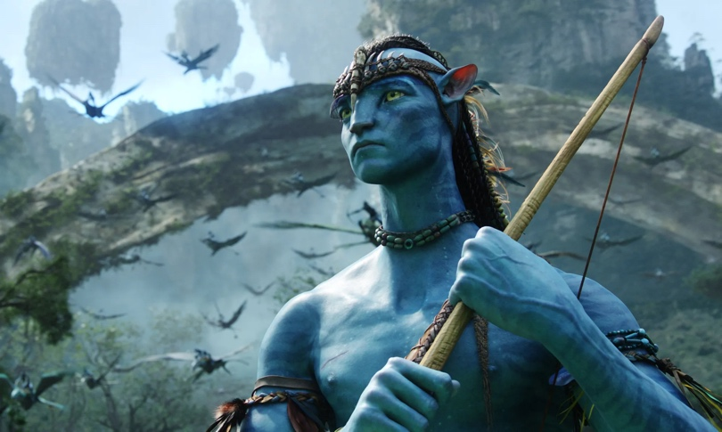Our first piece of content was created for Instagram. This post will be targeted towards Disney fans ages 18-30. We will we posting this on a Tuesday morning at 8:45 am CST. This time allows our audience in PST and CST to view the post before work, depending on start times. We are keeping time zones in mind to assure our post performs better. If we post at 8 am EST, that is 7 am CST and 5 am PST. This would cause a huge portion of our audience to not see our post. Our caption for this post will be, “Discover the all-new world of Avatar… Coming December 16th #AvatarTheWayofWater”. The purpose of this post is to give viewers a look as to what the movie will look like, which will A picture containing indoor
increase excitement. Our next post will be for Twitter targeting technology lovers ages 25-40. We will post this on a Wednesday at 8 am CST. The purpose of this post is to show the behind the scenes of filming, to make the viewer want to go see the movie theater as soon as possible. The caption for this post will be, “*Avatar: The Way of Water* is coming soon. Purchase your tickets to experience the groundbreaking film today.” This includes a call to action which will increase conversion rate, along with an exclusive look at filming which increases excitement. Our next post will be on TikTok targeting ages 18-25. It will be posted on a Friday at 7 pm CST, when everyone is on social media after work and school. The purpose of this post is to make the 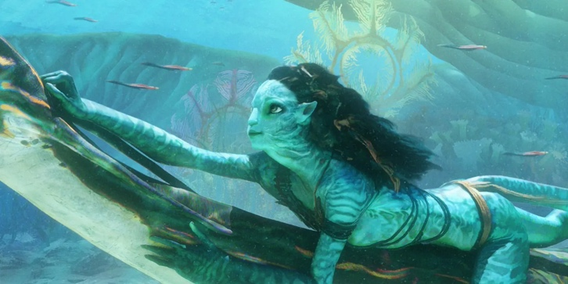viewers in a sort of awe. After watching the TikTok, we want viewers to be in awe of everything from the colors to lighting, to the entire video itself. This post will cause viewers to want to experience the film in theaters to see the incredible work of art. The TikTok will be fashioned as a mini trailer. It will have clips taken from the trailer along with a few new unseen clips. This TikTok will show them in the ocean riding an Ilu, the animal in the photo. This visual is what the TikTok video will be fashioned to look like. The video will have inspiring/moving music and will say, “The way of water connects all things. Before your birth, and after your death”. The caption will be, “What secrets does the water hold? Travel to the depths with us to find out. #AvatarTheWayofWater”. We believe this TikTok will go viral and increase our overall reach. Our last social post is for Facebook and is targeted towards Moms 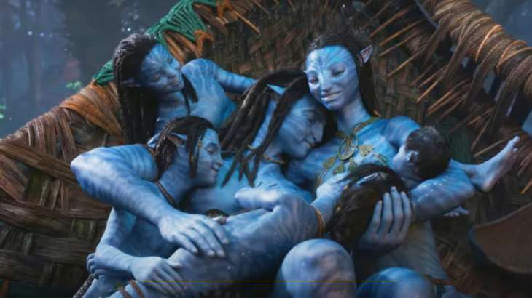ages 35-45. We will be posting this at 8 am CST on a Thursday. This will allow our audience to view it in the morning before their day. The purpose of this post is to encourage the audience to buy tickets to take their families to see this film in theaters. We are utilizing this visual to show that this movie is perfect for families, and everyone will love it. Our caption will be, “Grab your family to see the most anticipated film in history. Tickets are on sale now, click the link to purchase. #AvatarTheWayofWater #Avatar”. By including a call to action, with a direct link on the post, we will increase our click rate and conversion rate. The pre-event is aimed to increase excitement and anticipation. These social posts will help increase the hype to an all time high. In addition to our social posts, we plan to host a giveaway on social media. This giveaway will fly the winner and 3 guests to California for the red-carpet premier. To enter, participants will have to go to our website and enter their information, including their email. Not only will this contest increase our engagement and brand awareness, but we can also send promotional emails to them increasing awareness even more. Additionally, we will be holding a golden ticket contest, much like Willy Wonka. By buying a ticket to see the movie in theaters on our website, you will receive 1 code per ticket. You will then enter this code into our website to see if you won a golden ticket. There will be 10 golden ticket winners, these will be completely randomized. Each winner and their chosen guest will be flown out to attend an exclusive event. They will get to tour the set of *Avatar* and will get an exclusive screening to Avatar 3. This contest with drastically increase ticket sales in hopes they will win a golden ticket. It will also increase media attention creating more publicity for the film. By doing all these things, we can ensure that our movie release will be extremely successful.

**During-Event**

This phase will officially kick off the day of the premier. This event is extremely important for our success, due to the amount of press that will come from the event. The premier will make or break our marketing plan, which is why we have strategically planned it. Everything from who we invited, to where attendees sit, to the flow of the event has been planned to make the experience the best it can be. By doing this, we can ensure attendees have a positive experience to share on media sites. Since the premier will generate a lot of press, we will see a large increase excitement and conversion. Once audience see that their favorite celebrity or influencer loved the movie, they are going to immediately buy tickets. In addition to the premier, 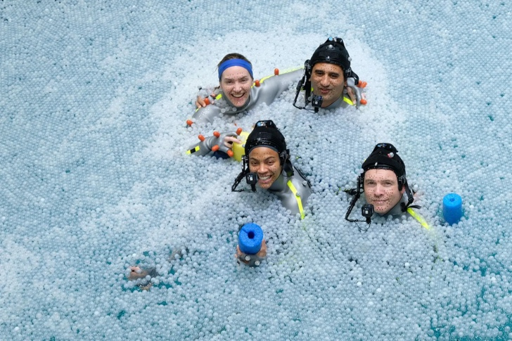our social posts are also extremely important. In this phase, our posts will be encouraging our audience to go see the film that is out now. The first post was created for Twitter and targets ages 25-35. It will be posted at 8am CST on a Monday. It is a behind the scenes post, that gives an inside look as to how the movie was filmed. Our caption for this post will be, “When shooting our underwater scenes, the combination of light and water created a surface reflection which interferes with the motion capture. Adding a layer of plastic balls blocks the lighting and prevents the reflection. Be sure to head to theaters to experience the technological advanced film today.” This post gives an insight into the production level of the film and encourages views to go see it. The photo alone shows a significant amount of technology that was required in filming. The caption adds a layer to that by explaining the purpose of a key element in the photo. This post will peak the audience’s curiosity as to what went into filming this movie and will increase anticipation. Our next post is for Instagram and is A picture containing swimming, water sport, ocean floor
targeted towards 18–25-year-olds, posted at 9am CST on Saturday. This post will be a multimedia gif post. We will have the reflections of the water and animals moving, capturing the eye of the viewer. The purpose of this post is to increase interest and conversion rate, as we included a buy ticket now button on the post. This post will also have an increase in engagement rate since it is a multimedia post. The caption will be, “Dive down deep into the wondrous secrets Pandora holds. #20thCenturyStudios”. Our next post will be for Facebook targeting parents ages 25-40. It will be posted on Thursday at 8 am 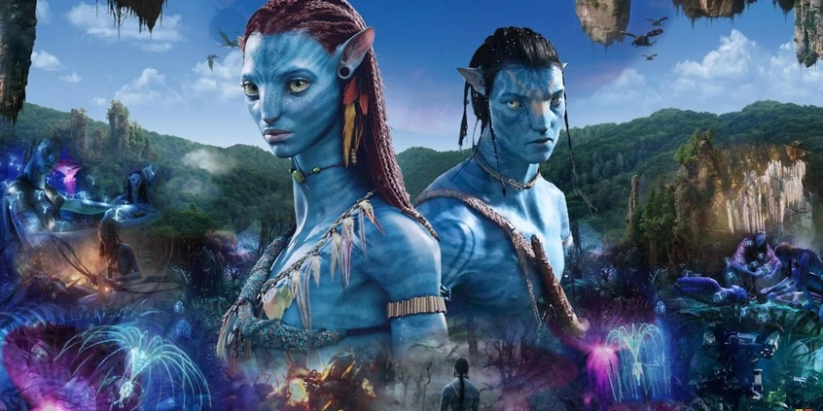CST. The purpose of this post is to bring awareness to the film and encourge parents to take their kids to the theater. Our caption for this post will be, “Experience the record breaking Disney film today. The visually appeailing world of *Avatar* is perfect for all ages. Purchase your tickets today!”. We included a call to action as well as mentioning it is perfect for everyone. Finally, our Tiktok will be targeted towards ages 16-25. We will be targeting a different audience by creating this content surounding the war. This allows us to increase brand awareness and intrest. The 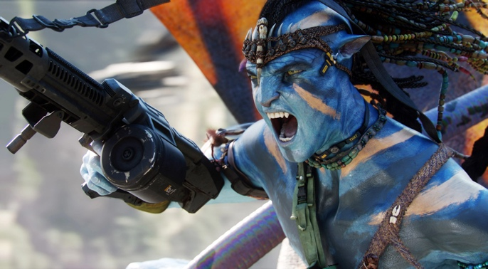Tiktok will be clips of the war and the main characters fighting back with their family. It will have intense music along with the words, “This is our home. This is our family. This is our fortress. We must protect our people.” Along with the caption, “They messed with the wrong family”. This caption aligns with our playful voice on this platfrom. These posts will encourage our audience to see the movie, which is extremely important to our success. By promoting to multiple different audiences, we can reach more consumers and increase our conversion.

**Post-Event**

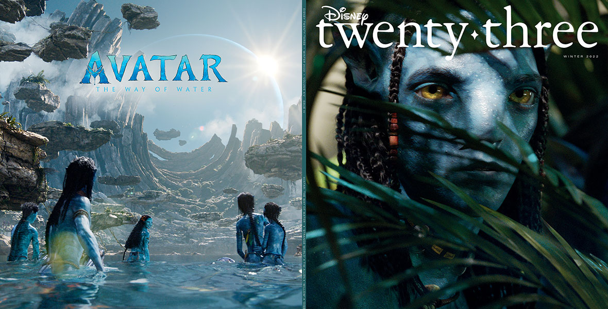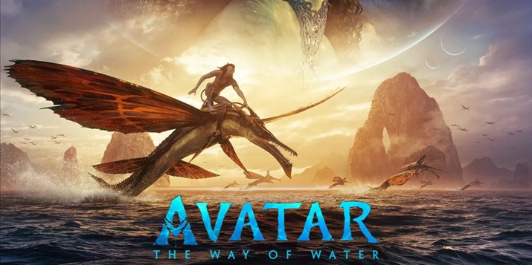This phase of our campaign kicks off once the movie is realease on dvd and streaming platforms. We will be releasing the movie exclusivley on Disney +. We will be offering an exclusive discount to sign up for the streaming platfrom, increasing our profit overall. By exclusivley releasing it on Disneys streaming platform, we keep all of the profits and increase brand awareness overall. Our first post for this phase is on Facebook, targeting parents ages 25-50. It’s purpose will be to encourage parents to watch the new movie on Disney +. We will be post this on a Firday at 6 pm CST. Our caption will be, “Watch the most anticipated movie in history.. now streaming exclusivley on Disney + #20thCenturyStudios #Avatar”. This caption includes a call to action encouraging our audience to watch the movie on Disney +. This will increase streams and in turn increase profits. This photo used is visually appealing and captivates you into the world of *Avatar*. Our next social post is for TikTok and will be targeting ages 18-25. We will post this on a weekday during the evening. This TikTok will be clips from the movie of them flying through the sky. It will include uplifting music and will say “No matter where we go, we will always be together.” The caption will say, “Nothing will tear us apart #Avatar”. This caption aligns with our voice for this platform and is short and simple. This post is promoting the movie by peaking interest in the viewer. By creating a cinematic quality TikTok, we will increase our engagement and potentially go viral. This helps promote the film and increases awareness. Our next social post is another technology-based Twitter post aimed towards ages 25-35 and will be posted at 8 am CST. This post will include another behind the scenes photo and will encourage viewers to watch now. We will be releasing a special 20 minute behind the scenes short film. This will be played exclusively after the movie on Disney +. The purpose of this Twitter post is to promote this special feature and encourage them to go view it. The caption will be, “Go behind the scenes with James Cameron as he shows what went into filming *Avatar: The Way of Water*. Now exclusively streaming on Disney + 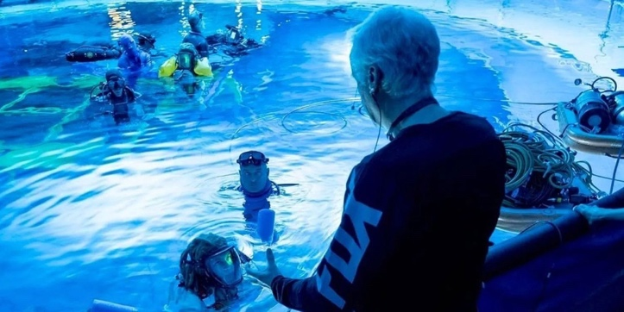#AvatarTheWayOfWater”. The visual along with the caption encourages the audience to take action and watch the new exclusive look. This post will increase engagement along with conversion rates. We will also be posting about the exclusive behind the scenes with James Cameron on multiple platforms. Our final post for this phase is on Instagram and will be targeted towards ages 25-40. It will be posted on a Monday at 9 am CST and will target all movie lovers. This post will be another multimedia gif post that will grab the attention of the viewer. The gif will have letters appear that says, “Now Streaming”. The purpose A picture containing text, outdoor
of this post is to encourage our audience to stream this movie today. Our caption will be, “You don’t want to miss the world renown film, now streaming on Disney + #AvatarTheWayofWater #20thCenturyStudios”. All the social posts during the post-event phase are aimed at increasing streams on Disney +. We want to remind and encourage our audience that the movie is now available to watch. These posts will increase this awareness and streaming on Disney +. In addition to these social postings, on Disney + we will make *Avatar: The Way of Water* the key movie when you first open the app. This movie will be the first thing you see when opening the app and will increase streams and recognition.

**Conclusion**

While I believe every phase of this marketing plan is extremely important for the success of this film, in my opinion the pre-event phase is the most important one. The pre-event phase builds the anticipation and excitement of viewers. Our efforts cause them to want to see the movie in theaters as soon as it is released. This phase increases film awareness and is what drives sales. Without this phase, the movies would not do nearly as well in theaters. This phase is 100% the reason for record breaking profits at the box office. I also think the premier part of the during-event phase is also extremely important. The premier generates a ton of press that reaches all different kinds of audiences. This event also is a huge factor in the success of the film. Additionally, I believe that TikTok is the most successful social platform for marketing *Avatar: The Way of Water.* When we created these cinematic, visually appealing videos, they would go viral and receive millions of views. This kind of reach is unlike anything we would receive on other platforms. We are able to reach people that we wouldn’t have normally. This helps our performance in theaters and increases our brand recognition overall. If I was chosen for the marketing strategy of this movie again, I would change a few things. First, I would start the marketing strategy a little bit earlier. I think I would start promoting the movie on social media around July. While there are pros and cons to both, I think starting earlier next time might help performance. Next, I would host more events surrounding the movie release. While I did host the event at D23, I think I would host either 1 or 2 more of this type of event. I think having more than 1 will increase excitement and build even more anticipation. Finally, I would post less on Facebook and more on TikTok. While Facebook is great for targeting a different audience, it receives a very low engagement rate. TikTok is by far the best social platform due to the sheer amount of engagement on the platform and low costs. By focusing on TikTok, we can increase engagement and cut down on cost. Overall, I believe our social media marketing plan was extremely successful. We utilized everything we could to target different audiences. *Avatar: The Way of Water* is a worldwide sensation and will completely change the industry. Our marketing plan highly contributed to the success at the box office and was key to the film’s success.

References

*Avatar Growth: Path social*. Path Social |. (2021, July 22). Retrieved November 27, 2022, from https://www.pathsocial.com/growth/?username=avatar

*Avatar Instagram Analytics*. (n.d.). Retrieved November 27, 2022, from https://socialblade.com/instagram/user/avatar

*Avatar's (@avatar) instagram profile* . (n.d.). Retrieved November 27, 2022, from https://www.instagram.com/avatar/

Buchanan, K. (2022, October 25). *James Cameron and the cast of 'avatar: The way of water' hold their breath*. The New York Times. Retrieved November 27, 2022, from https://www.nytimes.com/2022/10/25/movies/avatar-way-of-the-water-james-cameron.html

Cooper, P. (2022, November 9). *The best time to post on Instagram in 2022 [Complete guide]*. Social Media Marketing & Management Dashboard. Retrieved December 2, 2022, from https://blog.hootsuite.com/best-time-to-post-on-instagram/

Cruz, A. (2022, November 2). *Fans mesmerized with the VFX of avatar: The way of water: Would it set the new benchmark for films?* FandomWire. Retrieved December 4, 2022, from https://fandomwire.com/fans-vfx-avatar-the-way-of-water-benchmark-films/

Donaldson, K. (2022, June 3). *The real reason the avatar sequels took so long*. ScreenRant. Retrieved November 27, 2022, from https://screenrant.com/avatar-2-sequel-release-date-delay/

Harris, H. (2022, November 23). *All of the avatar sequel announcements: A timeline*. Vulture. Retrieved November 27, 2022, from https://www.vulture.com/2022/11/avatar-sequel-announcements-timeline-james-cameron.html

IMDb.com. (2009, December 18). *Avatar*. IMDb. Retrieved November 27, 2022, from https://www.imdb.com/title/tt0499549/?ref_=nv_sr_srsg_0

IMDb.com. (2022, December 16). *Avatar: The way of water*. IMDb. Retrieved November 27, 2022, from https://www.imdb.com/title/tt1630029/?ref_=nv_sr_srsg_3

Libbey, D., & Wiese, J. (2022, June 27). *Avatar 2: What we know so far*. CINEMABLEND. Retrieved November 27, 2022, from https://www.cinemablend.com/new/Avatar-2-What-We-Know-So-Far-42507.html

Liu, N. (2022, September 11). *Avatar: The way of water wows at D23, reveals New concept art*. CBR. Retrieved December 4, 2022, from https://www.cbr.com/james-cameron-avatar-the-way-of-water-concept-art-footage-d23/

Mensah, J. (2022, November 22). *Avatar 2: Release date, trailers, cast and what to expect from the way of water*. Radio X. Retrieved November 27, 2022, from https://www.radiox.co.uk/news/tv-film/avatar-2-title-release-date-cast-plot/

Nick Romano By Nick Romano November 10, 2022 at 04:01 P. M. E. S. T. (n.d.). *James Cameron breaks down 4 key 'avatar: The way of water' scenes*. EW.com. Retrieved December 4, 2022, from https://ew.com/movies/avatar-the-way-of-water-james-cameron-scene-breakdown-interview/

Patches, M. (2020, May 13). *The making of avatar 2 looks like absolute hell*. Polygon. Retrieved December 4, 2022, from https://www.polygon.com/2020/5/13/21257520/avatar-2-cast-water-tank-image-behind-the-scenes

Powers, 3.8.2022 K., Powers, K., & Katie Powers is editorial content intern at the American Marketing Association. (2022, September 12). *The best times to post on social media in 2022*. American Marketing Association. Retrieved December 4, 2022, from https://www.ama.org/marketing-news/the-best-times-to-post-on-social-media/

Rich, K. (2022, November 22). *Can 'avatar: The way of water' be as good as James Cameron's interviews about it?* Vanity Fair. Retrieved November 27, 2022, from https://www.vanityfair.com/hollywood/2022/11/can-avatar-the-way-of-water-be-as-good-as-james-camerons-interviews-about-it

Rubin, R. (2022, April 27). *James Cameron's 'avatar 2' debuts visually dazzling footage at CinemaCon, gets official title*. Variety. Retrieved November 27, 2022, from https://variety.com/2022/film/news/avatar-2-footage-james-cameron-cinemacon-1235234293/

Sharf, Z. (2022, October 25). *Zoe Saldaña held her breath underwater for five minutes while filming 'avatar 2,' James Cameron hired 'World's best breath-hold specialists'*. Variety. Retrieved December 4, 2022, from https://variety.com/2022/film/news/zoe-saldana-avatar-2-training-held-breathe-5-minutes-underwater-1235413876/

Sohrab. (2022, November 7). *Disney twenty-three journeys to pandora, going behind the scenes of the next-level storytelling of avatar: The way of water*. D23. Retrieved December 4, 2022, from https://d23.com/disney-twenty-three-journeys-to-pandora-going-behind-the-scenes-of-the-next-level-storytelling-of-avatar-the-way-of-water/

*Top lifetime grosses*. Box Office Mojo. (n.d.). Retrieved November 27, 2022, from https://www.boxofficemojo.com/chart/top_lifetime_gross/?area=XWW

Wikimedia Foundation. (2022, November 23). *Avatar (2009 film)*. Wikipedia. Retrieved November 27, 2022, from https://en.wikipedia.org/wiki/Avatar_(2009_film)